Name ________________________ Date _________________________
Intro to Physics Alternative Energy Project
Period _____________ Mrs. Nadworny

Due Date ______________________

Alternative Energy Project

Objective
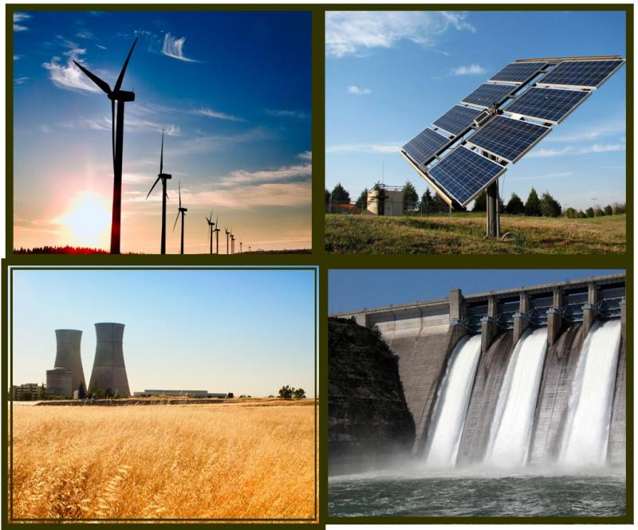
To research alternative forms of energy.

What is Alternative Energy?

Alternative energy is any form of energy that does not come from fossil fuels. They are considered alternatives because they can be future replacements for the fossil fuels that now meet a considerable portion of our energy needs.

Alternative Energy Options
Requirements

You will research each of the alternative energy resources. You’ll complete the note sheet for each one with information on the following facts:

- Definition of your energy resource
- Explain whether the resource is renewable or non-renewable
- How is the energy resource produced and how do we recover it?
- Explain ways we turn the energy resources into energy we can use.
- Explain who uses this energy resource and for what purposes
- Advantages of using this energy resource (environmental factors)
- Disadvantages of using this energy resource (environmental factors)
- Important random facts about the energy resource
Quiz Questions

Write three quiz questions related to each energy resource. The questions may be in the form of multiple choice, true/false, fill in the blank, matching, short answer, etc.

Also, answer the questions you’ve created using the information from your notes.

